- Navigation: PeopleSoft HR> Main Menu> Payroll for North America>Payroll Distribution> Commitment Accounting> Department Budget Table USA (This navigation can be added to your Favorites to save time.)
  - The available list of Departments is dictated by the Security Form that was submitted to HR
  - Please enter the following fields to pull up the Position:
    - Department ID
    - Fiscal Year (optional)
    - Position number

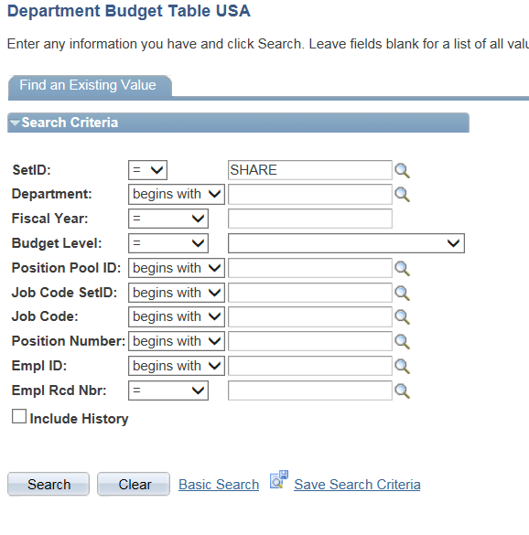

- Press the Search Button to display the position’s information.

- The position’s Dept. Budget Earnings Tab or “DBE” information has a few sections.
  - Top Portion indicates what Department the Position “lives” in. In this example, the position “lives” in Department 10494 Sociology Dept.
  - Middle Portion indicates the “Level”. UMBC uses “Position” as the level to budget regular positions, so we have the radio button as “Position”.
  - Bottom Portion is the “Earnings Distribution”. This indicates the funding source and percentage.
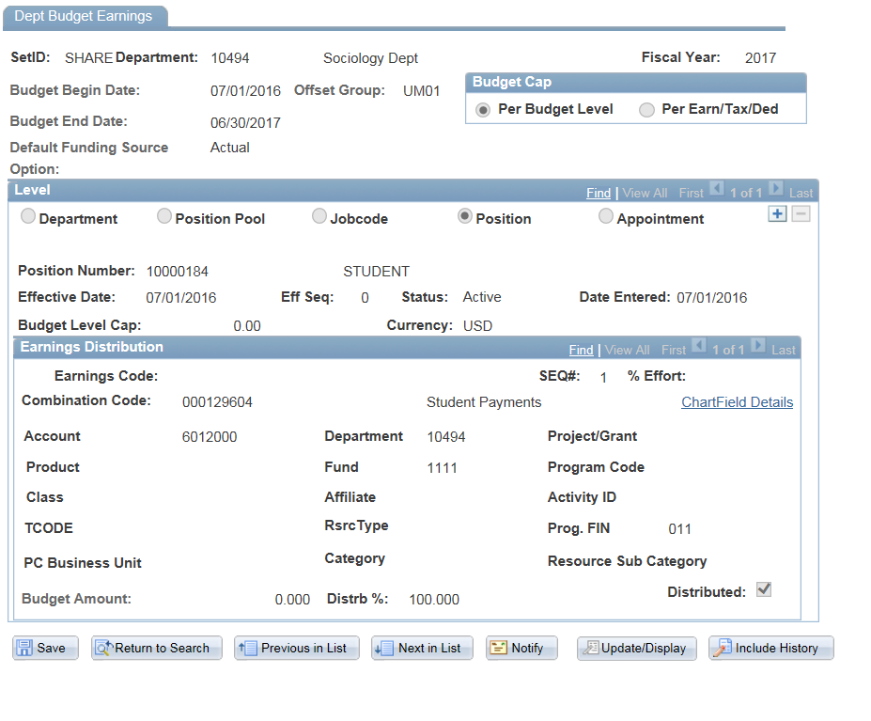
- The common reasons for changing the “DBE” for a position are:
  - Position’s funding source changed or ended.
  - Position was reclassed and account number needs to be changed.

- To change the Funding Source, please perform the following steps:
  - Press the + Key on Middle Section “Level”
  - The Date field will become writable.

Step 1, press + key

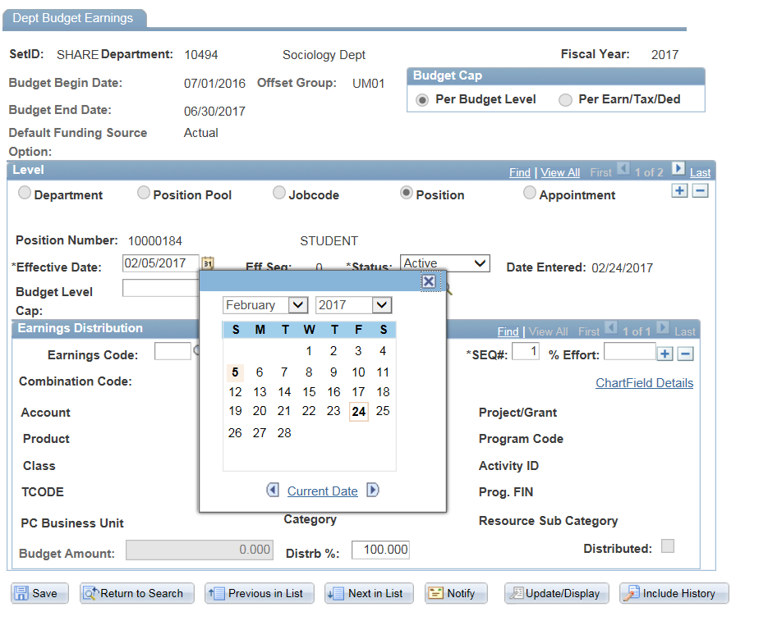

Step 2, change the Date from the System Date to the Date at the start of the Pay Period or Funding Source.

- Step 2 requires that you have the Payroll Calendar on hand. There are separate business processes dictating the Start of a Payroll for Salary/Contingent employees vs. Hourly employees.
  - In our example, the position is a Student Position, so it would fall on the Hourly (HRL) side of the Payroll Calendar. So we will be using Start Date = 02/05/17.
  - *IF* we were working on a Salary (SAL) Position, we would use 02/19/17.
  - It is possible to deviate from these Start Dates in the situation where a Grant Starts midweek. Then you would put the date the Grant begins as the date.
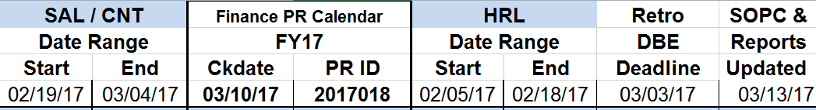

- Once the Date is selected, move onto Step 3.
- Step 3, Click on the “Chartfield Details” Link.
- This link ONLY displays ACTIVE funding sources.

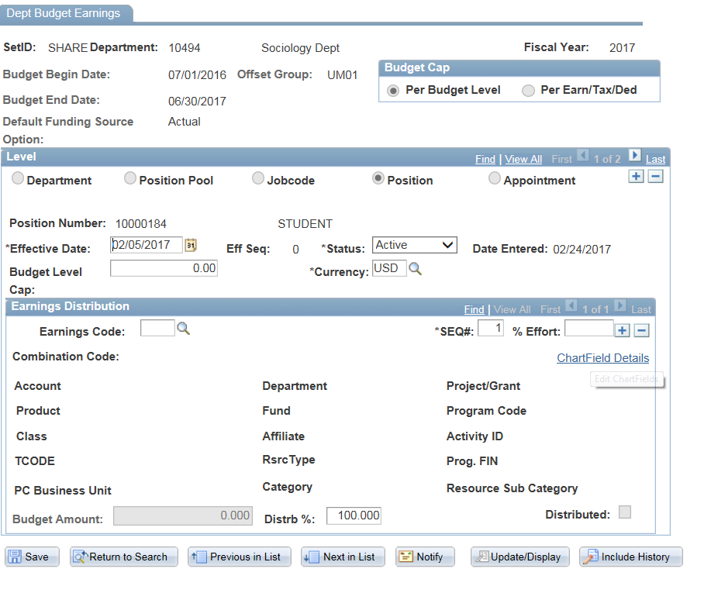

Step 3, Click on the link “Chartfield Details”

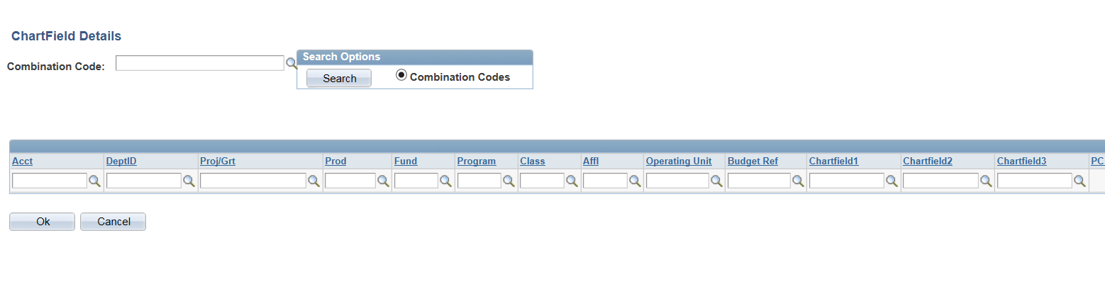

Step 4, Enter the Combination Code
OR
Enter some Chartstring information below

Have Combination Code | Do NOT have Combination Code
- Enter Combination Code  - Press OK Button | - Enter a few important fields from Chartstring, such as:  Account, Department, Fund, Project  - Click Search Button  - Press Select Button once you have found the Chartstring on list.  - Press OK Button

11.0 Once the Chartstring information has been entered, you will be back on the DBE screen.

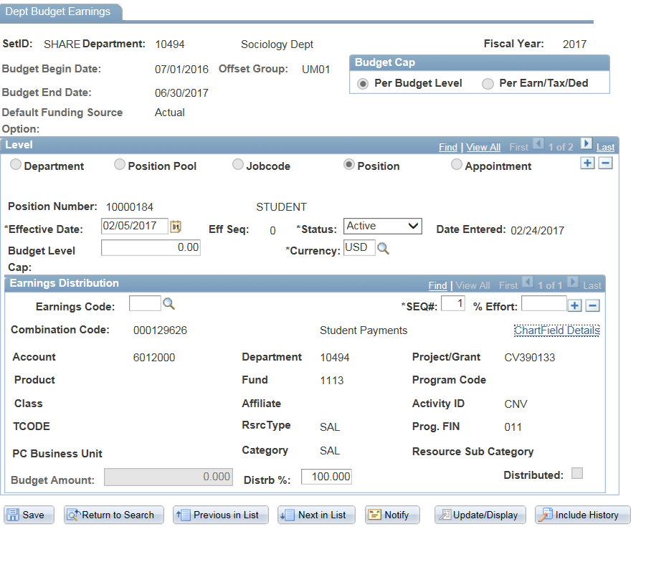

Step 5 Important:
Confirm that
Effective Date,
Chartstring,
and Distrib % is Correct

12.0 Once you have confirmed that Date, Chartstring, and Percentage is correct, please Press SAVE button.

  - The Position in the example is a HRL Position. After you click SAVE, there are two messages that appear each time. This is only for HRL positions, because UMBC has a special business process for paying HRL Positions.
    - On First message, ANSWER YES
    - On Second Message, ANSWER NO
  - If you receive these messages on a SAL position, it is possible that you went earlier than the Start Date of the current payroll. Check the date compared to the Payroll Distribution Calendar.

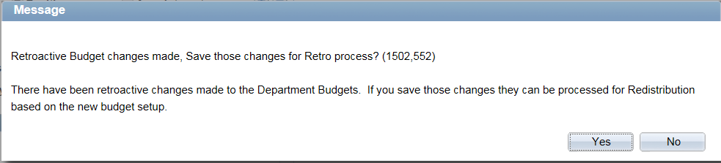
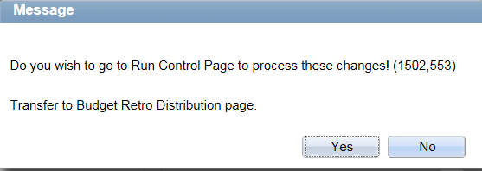

- It is possible to have Distrib % to be less than 100% and have Multiple Funding Sources.
  - SEQ# will always be = 1. It is a generic place holder. ALWAYS 1.
  - Press + key on the Earnings Distribution Section
  - Repeat Step 3,4,5 until the Distribution = 100%
  - The system will ONLY allow it to be SAVED if it is 100% or adds up to 100%.

