PeopleSoft 9.2 Training general information
Contents
Navigation 3
Overview 3
Landing Page - Employee Self Service 3
Navigating with Breadcrumbs 4
Navigating with Navigator 4
Favorites 6
Navigation 6
Add Favorites 7
Delete Favorites 7
Workcenters 8
Overview 8
Navigation 8
Security 11
My Work Section 11
Links Section 12
Queries Section 14
Reports Section 14
Search 15
Overview 15
Search from Employee Self Service 15
Search from Workcenters 16
Search from Breadcrumbs Search Bar 18
Filtering Search Results 18
Run Controls 20
Overview 20
Approvals 20
Navigation 20
Approve the Requisition 22

Navigation

Overview
The navigation in PeopleSoft 9.2 has seen a drastic improvement in comparison to the 8.9 menu navigation.
In an effort to make PeopleSoft more mobile and user friendly, they have rolled out a menu option of tiles. Tiles mostly point to various WorkCenters, but can also point to heavily used menu options, such as Approvals.

Landing Page - Employee Self Service
The tiles appear on a page called Employee Self Service. This is the default page you will see when logging into PeopleSoft.
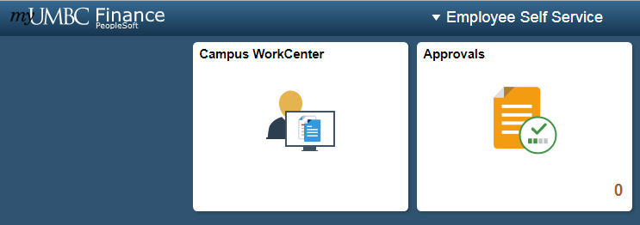
All campus users can use the Campus Workcenter to access everything that they regularly use in PeopleSoft. Departmental Approvers and Central Employees may also see a tile called Approvals.
If you see additional tiles, it means that you have more of a centralized role. Use those tiles to access menu options that relate to central tasks.
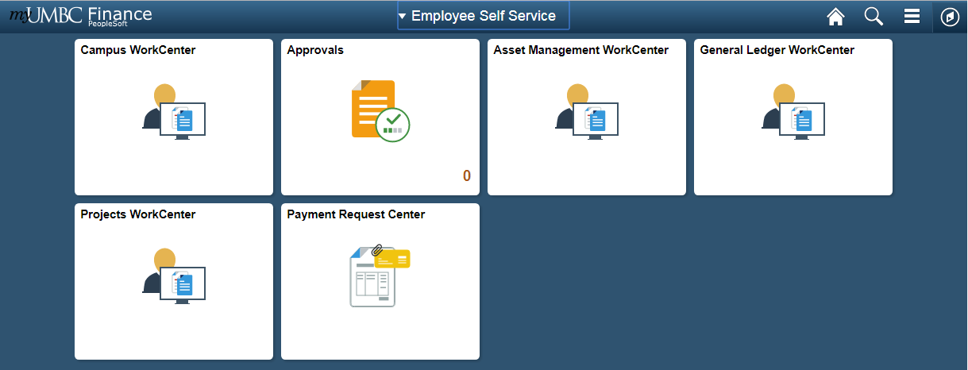

Navigating with Breadcrumbs
Once inside a workcenter, you will also notice that a top menu bar appears, showing breadcrumbs of where you’ve been.
This is an interactive bar that shows menu options in the same order as they appeared in 8.9.
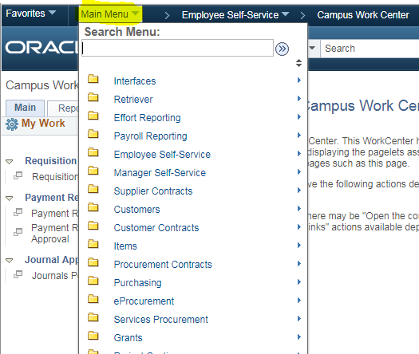

Navigating with Navigator
If you do not see the breadcrumbs at the top of the page (sometimes they are unavailable), you can access the menu options by clicking on the compass symbol called NavBar in top right hand corner of every page. This will bring up a side menu bar.
From there, click on the Navigator Menu option. This will bring up the main menu options in the same order that they appear in 8.9.
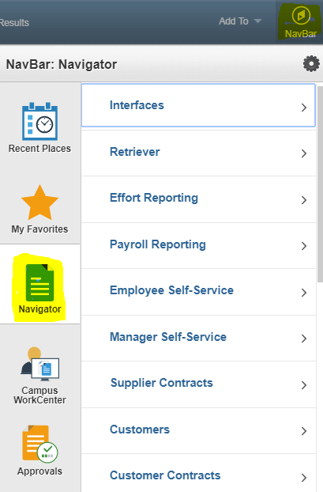
As a general tip, if you drill down to a specific menu option, the next time you go into Navigator it will “remember” the last menu option you drilled down to. So you may have to hit the back bar at the top of the navigator menu tree to see the main menu options again.

Favorites

Navigation
You can get to your favorites by one of two ways. The first is by using the top breadcrumb bar. The favorites will be right next to the main breadcrumbs, in the top left hand corner:
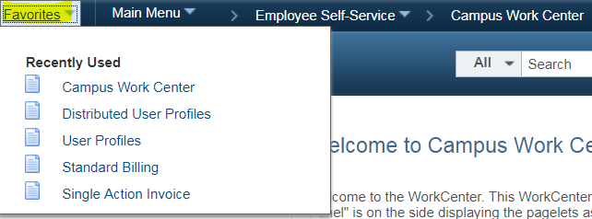
NOTE: You can only see this breadcrumb bar when in a workcenter or on some other page. You cannot access the breadcrumb bar from the home page (the Employee Self Service page).
The second way to access your favorites is by clicking on the NavBar icon in the top right hand corner of any page, which looks like a compass.
This will bring up a right hand side menu, and Favorites will be the second tile on this menu.
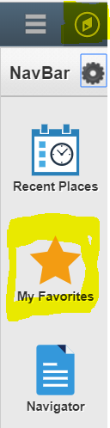

Add Favorites
To add to your Favorites, go to the page that you would like to add. Once there, look at the top bar on the right hand side. Select the dropdown arrow next to “Add To” and select Favorites.
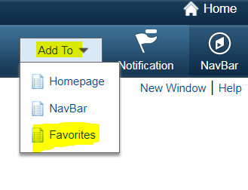
Edit the Description if needed and click OK
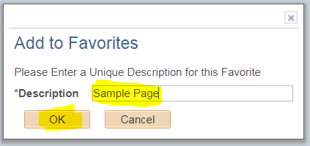

You will now see this link in your favorites when you navigate to them.

Delete Favorites
To delete favorites, go to the Favorites tile from the NavBar. After clicking on the tile, an additional side menu appears. Click on the top link that says Edit Favorites
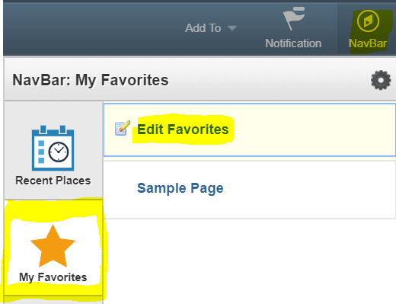
From there it will bring you to a page that lists out all your Favorites. Click on the box with a – sign next to the favorite you would like to delete.
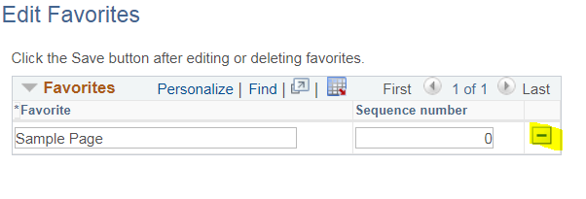
Click OK to the delete confirmation message.
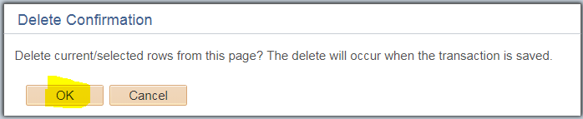
You will no longer see that Favorite in your Favorites bar.

Workcenters

Overview
Workcenters are designed to replace the old navigation seen in PeopleSoft 8.9 and before, to group together menu options regularly used based on your role in PeopleSoft. They reduce navigation time and let you accomplish your daily tasks in an efficient manner.

Navigation
All Workcenters are divided into four general areas. On the left-hand side you will see the navigation bar, with two tabs, and two sections on each tab.
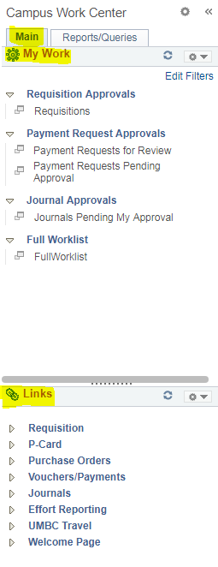

There are additional navigational tools for the pagelets that appear when your cursor hovers in the area: one is a right-hand vertical scroll area. You can left-click the scroll once it appears, hold down the cursor and drag the scroll bar up or down.
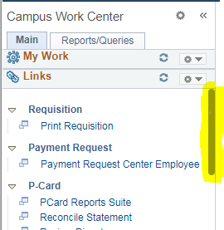
You can also resize each Workcenter pagelet. Just hover over the dotted line in each pagelet until the cursor turns into a double-sided arrow. Left-click and hold down. Drag and drop up or down to resize the pagelet.
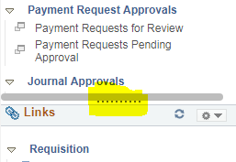
To collapse any of these sections so that you can focus on the sections that matter to you, select the dropdown arrow next to the gear icon, to the right of the section title. Select Minimize.
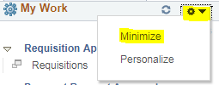
To expand the section, select the dropdown arrow next to the gear icon again, and select expand.
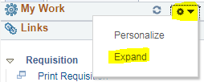
When clicking on any menu item, the page that correlates to that link displays next to the menu on the right hand side. You can hide the left hand menu options to give more real estate for the page you are actively working on. To do this, click on the << symbol at the top of the menu bar next to the Workcenter name.
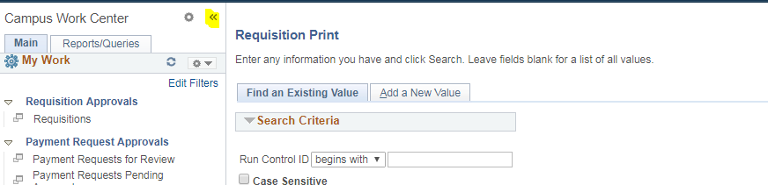
To get the menu back, simply select the >> icon (now in the top left hand corner of the page):
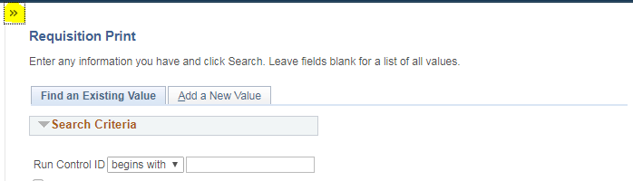

Security
Workcenter security follows user roles, permissions lists, and user ID setup. You will only see links to areas you have access to. If you don’t have access to an area, the link will disappear from the side menus.

My Work Section
On the main tab, you will see a My Work section with hyperlinks to task pages.
The My Work pagelet can include links to events and notification alerts, prioritized items needing immediate attention, and worklist tasks for workflow approval.
The pagelet is standardized for all agencies and will not be personalized.
The hyperlinks ONLY become active when you have tasks to complete in that section. Otherwise, the hyperlink is grayed out and you cannot click on it. Hyperlinks are only visible to a user if they have access to the corresponding pages they link to.
When a user has work to do, the hyperlink becomes clickable. A number will display in parenthesis next to the link letting you know how many items require attention in that area.
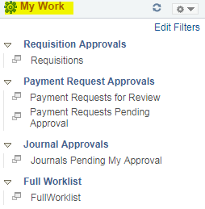

Links Section
The Links pagelet makes it possible for you to access your most commonly-used pages with full functionality without ever leaving your Workcenter.
Each pagelet can include group headings. Group headings are used to place similar pages and links into logical groupings, and are expandable and collapsible.
If you do not have access to all links under a group heading, that group heading will not appear for you.
The group headings themselves are not clickable. You have to select the dropdown arrow next to the group heading to expand the menu options, which opens up all links related to that group heading. Those links are clickable.
The Links pagelet can include additional links to pages and other areas of interest including links that are external to your organization.
You can personalize (from the list enabled by your system administrator) which links appear on your Workcenter.

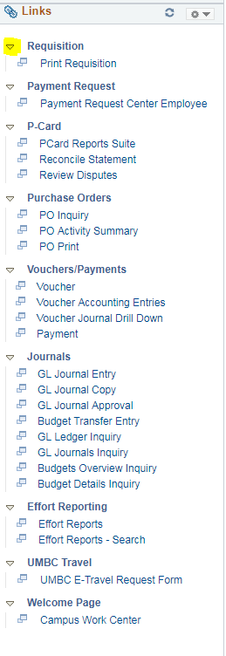

Queries Section
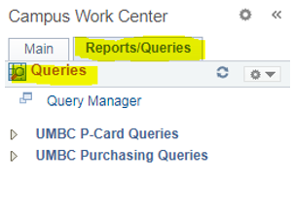
The Queries pagelet can include links to Query Manager, public queries, and pivot grids.
If there is a Query that you think will benefit the campus, you can reach out to IT to have a link added to the Campus Workcenter.
All queries that show up in the Workcenter will be available to everyone, so we cannot configure it for the individual user.
However, you can also view all your query favorites when you go to the Query Manager.

Reports Section
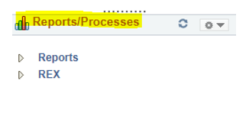
The Reports Pagelet an include links to reports frequently used by the campus. Examples include PCard Reports suite, and all REX reports.
These links take you directly to the Run Control page for the report or process.
There is a REX app that allows you to see and run REX reports within the PeopleSoft environment (only works in Internet Explorer).
If there is a Report that you think will benefit the campus, you can reach out to IT to have a link added to the Campus Workcenter.

Search

Overview
PeopleSoft 9.2 comes equipped with a new Elastic Search feature that allows you to search for anything, like you would in a Google search. It allows you to access menu options such as Add/Update Journal Entry, and specific items such as a specific Journal Entry.
One tip to keep in mind: be specific. If you are looking for a specific item, and you do not have the item ID, use search terms for other data about the item such as Entry Date, or Created By.
There are three main places that you can access the search menu. In Employee Self Service, in the Breadcrumbs menu bar, and via the Workcenters.

Search from Employee Self Service
From the Employee Self Service page, you can locate the search menu by clicking on the magnifying glass.
Put your search terms in the Search field and click enter.
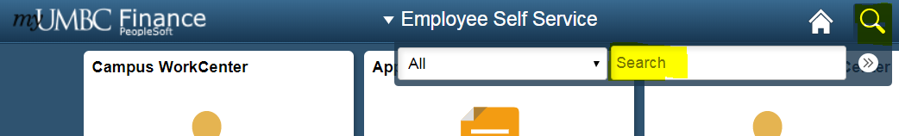
To get to a more advanced search, click on the >> button next to Search. It will bring you to a blank page with a search pane on the left hand side. Click More Options to see more advanced search settings and fields.
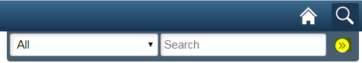
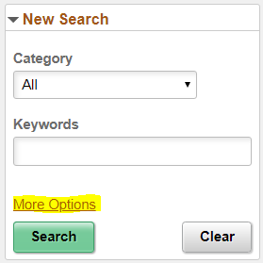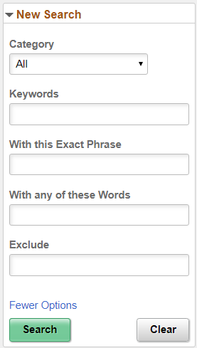

Search from Workcenters
From any Workcenter page, you can search by typing in search terms in the search bar at the top of the page.
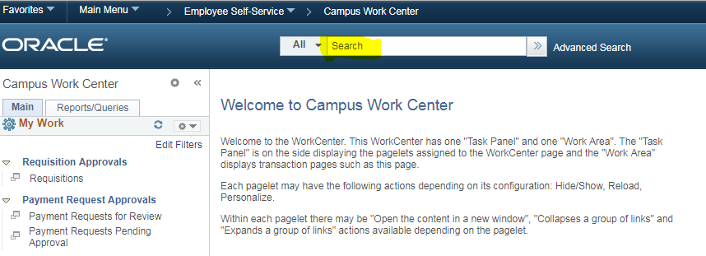
Select the All button to bring up different categories. This will filter your search results so that they only relate to that specific category.
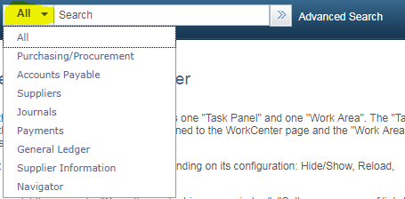
For a more advanced search, click on Advanced Search. It will bring you to a page with more advanced fields and filter criteria.
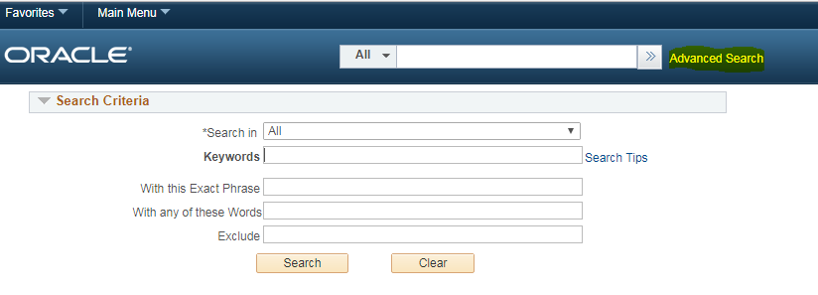
For some advanced search tips, be sure to click on the link Search Tips. A popup will appear with some helpful tips to maximize the advanced search features.
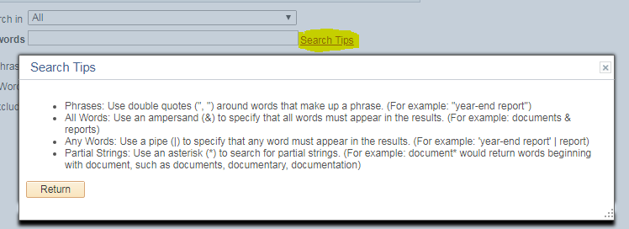

Search from Breadcrumbs Search Bar
You can also search for menu items when clicking on the dropdown menu options from the breadcrumbs search bar. Just enter your search terms in the search field.
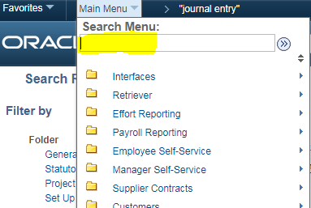

Filtering Search Results
The Search Results page will list out a series of clickable links to specific menu options or items. It tells you how many total results there are. You can use this as a meter and use more information to narrow the search results.
A category menu on the side will allow you to show items only related to that category. Click on the link that most relates to what you’re looking for.
You can conduct a new search by selecting the arrow next to New Search in the top left hand corner. Select More Options for a more advanced search.
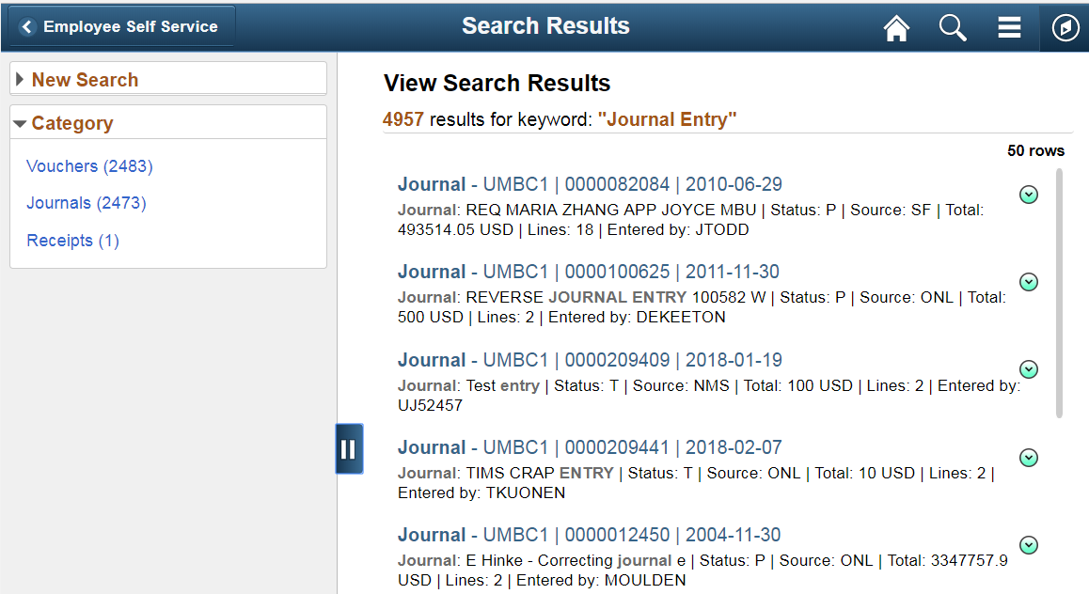
You can conduct a new search by selecting the arrow next to New Search in the top left hand corner. Select More Options for a more advanced search.
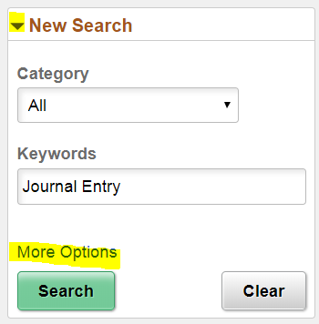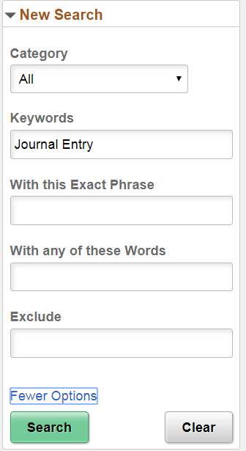

Run Controls

Overview
IT will be removing all Run Control ID’s during the 9.2 implementation. This is a common practice when doing such a large upgrade because often times the tables have changed drastically in the background. When a person tries to use a previously defined Run Control ID from an old environment in the new environment, it will often cause an error.
IT will be implementing a read only environment that will allow you to visit your old Run Control’s if you ever need to visit them to remember how they were set up. You will have to set up your own Run Controls in 9.2

Approvals

Navigation
If you need to approve an item as a departmental approver: Go to the Employee Self Service Page and click on the Approvals Tile.
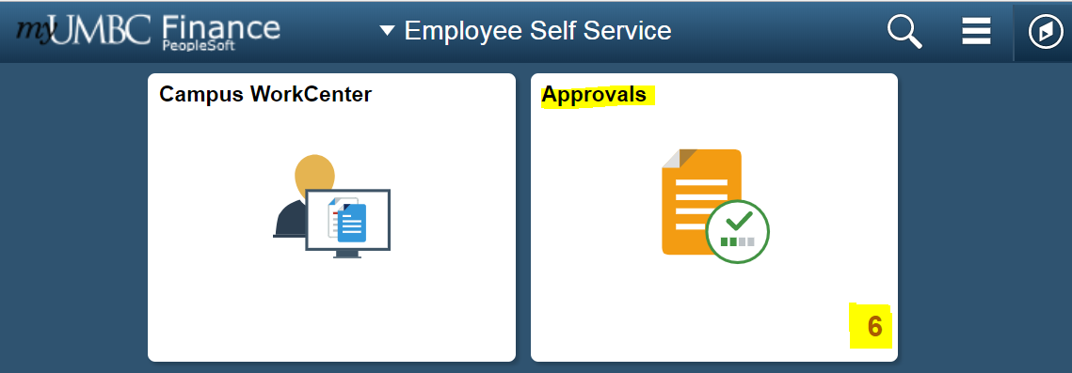
All items requiring your approval are listed here. You can select on the left hand side which area you would like to work with (i.e. Journal Entries, Payment Requests, Budget Transfers, Requisitions, etc.)
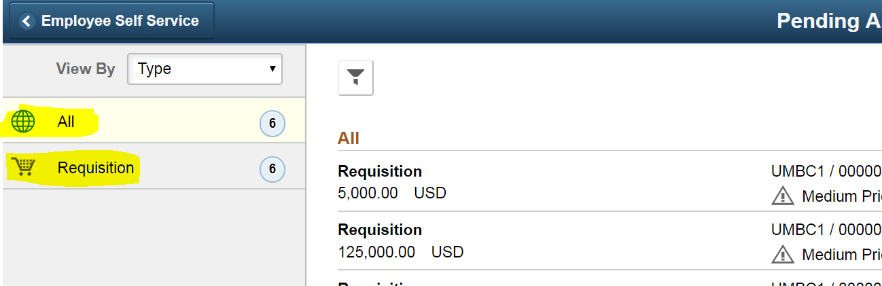
Once filtered down, select the item from the list that you would like to approve. The item name, number (ID) and the person who submitted it can be seen from the review list.
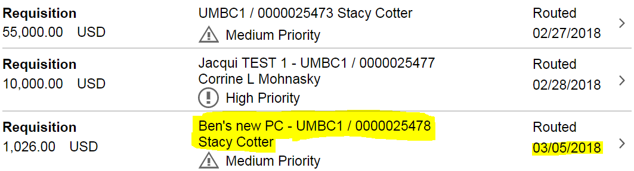
Click on the link of the Requisition you would like to review.

Approve the Requisition
To approve or deny the item, fill in the appropriate comments into the Approver Comments section at the bottom, and select Approve or Deny in the top right hand corner
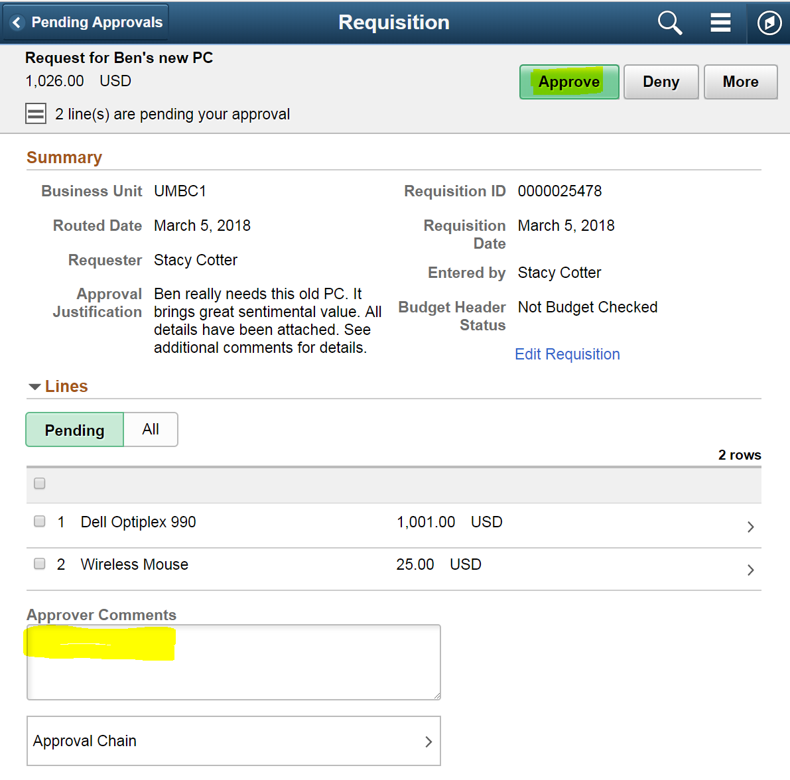
A popup will appear with your approver comments pre-loaded in it. Change your comments if needed. Click Submit.
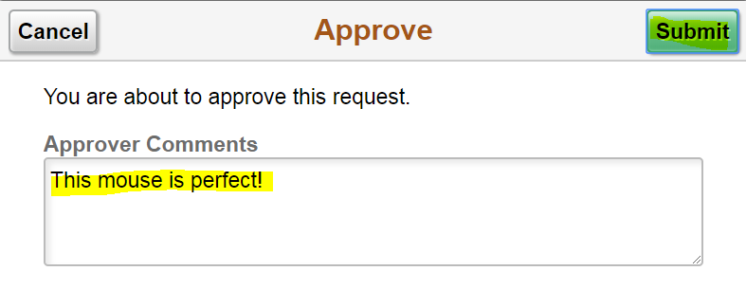
After approving it will go through central approval and disappear from your worklist.

