Journal Edit Process Before Approval Taking Too Long

We have been experiencing performance issues during the journal edit/process before submission for approval. This causes the edit process to complete in 3-4 minutes, but the screen does not refresh, spinning endlessly.
Interim Workarounds:
- If you already have started the process and it is spinning, you may be able to click on the Campus WorkCenter breadcrumb and at least return to a working screen. Click on “Journals to Take Action” and proceed to submit your journal for approval.
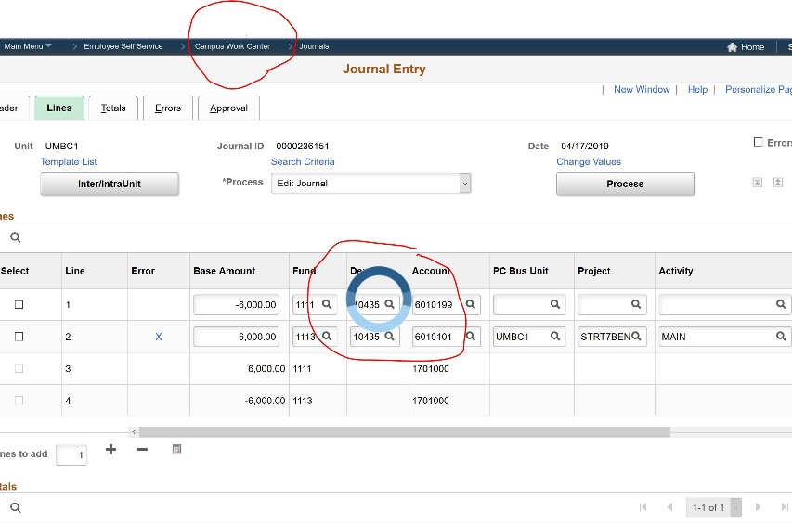
- If you haven’t started, you can start and simply answer “No” when asked “Would you like to wait for confirmation that the Edit process has complete? (5010,465).” After 3-4 minutes, your journal should be ready for approval submission (or in error status if it did not pass edits).
