PeopleSoft 9.2 Journal Entry
Contents
JOURNAL ENTRY NAVIGATION 2
JOURNAL HEADER 2
STEP 1: ADD A NEW VALUE 3
STEP 2: JOURNAL HEADER 4
STEP 3: JOURNAL ATTACHMENTS 5
STEP 4: BUSINESS PROCESS FOR JE ATTACHMENTS 6
JOURNAL LINE ENTRY 7
STEP 5: ENTER LINE INFORMATION 7
STEP 6: EDIT JOURNAL 8
SUBMIT FOR APPROVAL 10
STEP 7: SUBMIT JOURNAL ENTRY 10
STEP 8: JOURNAL APPROVAL INFORMATION 11
STEP 9: NOTIFY OTHER CAMPUS DEPARTMENTS 12
JOURNAL ENTRY FEATURES 13
STEP 10A: FIND AN EXISTING VALUE 13
STEP 10B: JOURNALS TO TAKE ACTION LINK 14
STEP 11: JOURNAL ENTRY COPY 14
STEP 12: JOURNAL ENTRY REVERSAL 16
APPENDIX A: JE HELPFUL HINTS 9.2 17
APPENDIX B: COMMON CHART STRING ERRORS 18
APPENDIX C “COST TRANSFER PROCEDURES ON SPONSORED PROJECTS 19

JOURNAL ENTRY NAVIGATION

JOURNAL HEADER
After logging in, access the Campus WorkCenter.

On the left hand side, under Links, select the dropdown arrow next to Journal Entry. Select GL Journal Entry.

STEP 1: ADD A NEW VALUE
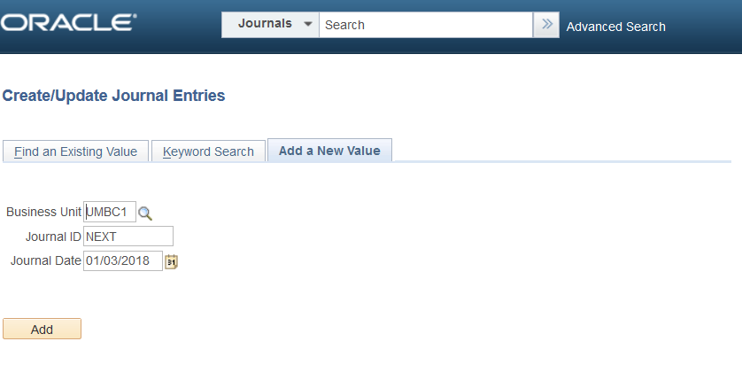

On the Add a New Value Tab, the default values are “UMBC1”, “NEXT” and Journal Date.
IMPORTANT: Journal Date dictates the Fiscal Period and Year
Journal Date is the current date, unless it needs to be changed per Monthly Journal Entry Deadlines.
Monthly JE Deadline emails are sent by Financial Services with the sponsored funds and non-sponsored funds deadlines. If you miss a sponsored fund journal entry deadline, please FUTURE DATE the journal to go into the NEXT Fiscal Period.
For example, if you miss January Deadline, please put February 1, so the journal goes into the next month.
To create a new Journal Entry, Press the ‘Add’ Button.

STEP 2: JOURNAL HEADER
This screen is the Journal Header. The Long Description, next to the arrow, holds 254 characters. This is where you type the purpose of the Journal.
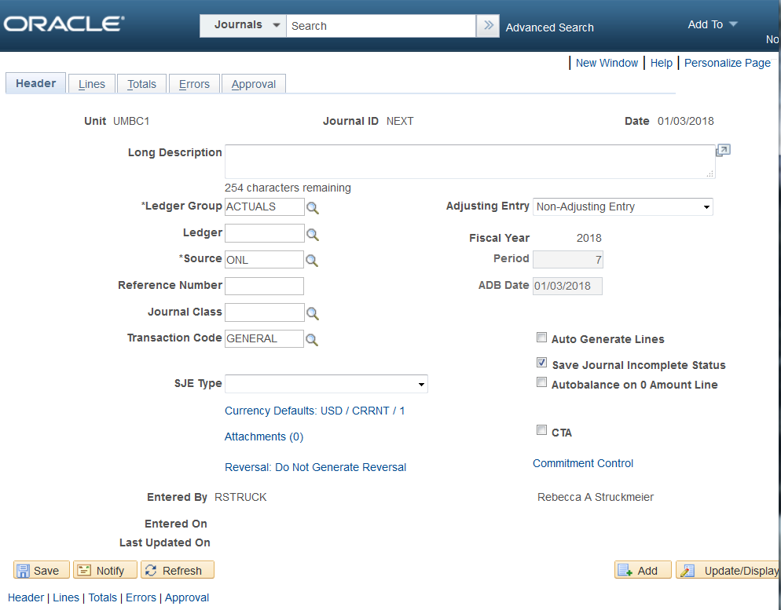
Long Description is the *ONLY* field in this upper section to modify.

A new 9.2 Feature in the Journal Entry process is Attachments, which will save the backup supporting the journal in PeopleSoft Finance. This can be viewed by anyone on campus, so please avoid sensitive data, such as social security numbers.
‘Attachments’ is the only link to modify here

STEP 3: JOURNAL ATTACHMENTS
After clicking the Attachments Link, it will bring you to this screen.
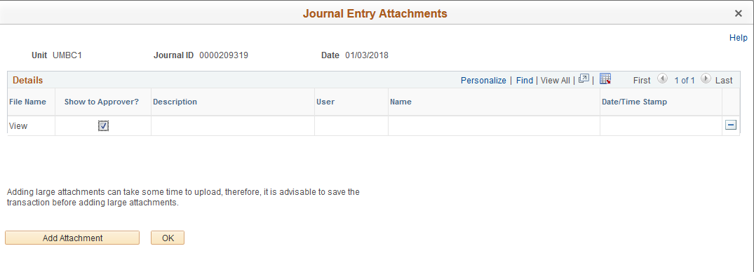
Please leave the box next to “Show to Approver?” checked.
Please click Add Attachment.
  - Browse button to select File, select the file, Click Open button to select.
  - Click Upload button to attach.
  - For 1 file, click OK button. For 2 or more files, click Add Attachment again.
  - For each file, please enter a Description that will assist the Approver in understanding the purpose of the attachment.
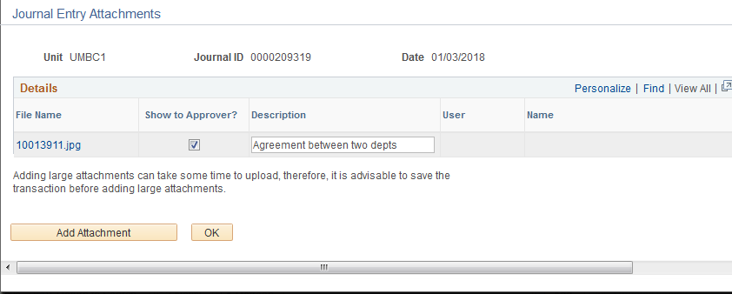

STEP 4: BUSINESS PROCESS FOR JE ATTACHMENTS

Business Process for Attachments:

Attachments should be supporting information for the Approver to better understand the purpose of the transaction.
Examples of attachments:
- Detail report from REX Finance
- Pcard report
- Grant Detail Report
- Scanned Emails indicating that Department A is supporting Department B
- Scanned Formal agreements indicating ongoing financial support to/from departments on journal lines.

Sponsored funding requires backup for Cost Transfers. For details and deadlines on Cost Transfers, please visit:https://cga.umbc.edu/cost-transfer-procedures-on-sponsored-projects-2
The attachment follows the Journal Entry and can be viewed by anyone on campus. Please avoid attachments with sensitive information.

JOURNAL LINE ENTRY

STEP 5: ENTER LINE INFORMATION
Now that an appropriate Attachment has been included, please click on the ‘Lines’ Tab.
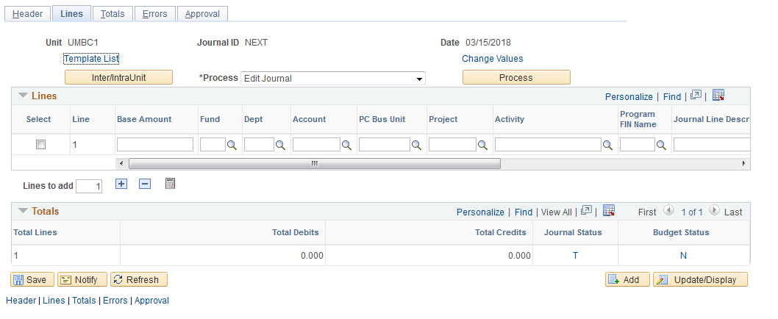
The next steps are to enter the Journal Line chartstring information. See “Journal Entry Helpful Hints” at the end of this document for help with some of the chartfield data entry, including Debit or Credit information.
Enter chartfield information by typing the information into the fields or selecting the magnifying glass. IMPORTANT: Start with your department chartstring on line 1, because those approvers will have the worklist items.
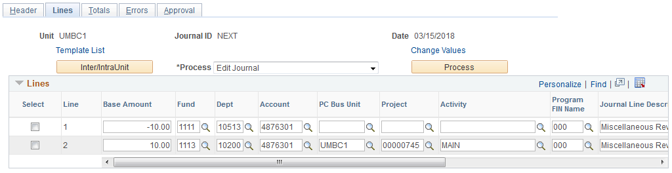
Now that the journal has been entered, please click ‘Save’ in the lower left hand corner. This will change Journal ID from NEXT to a 10 digit number.

STEP 6: EDIT JOURNAL
Next, Press ‘Process’ button while the ‘Edit Journal’ option is selected.

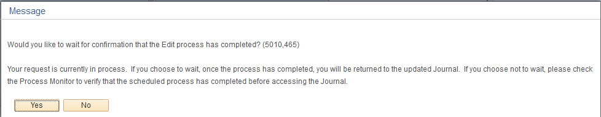

Answer ‘YES’ if you would like to wait while system processes the journal.
Answer ‘NO’ if you want the edit process to run in Process Monitor, so you can continue onto another task. Then submit for Approval via the Approval Tab via “Find an Existing Value Tab” or “My Work”. See Table of Contents.

After the Edit Journal Process runs, it creates internal account numbers to auto balance by fund shown below.
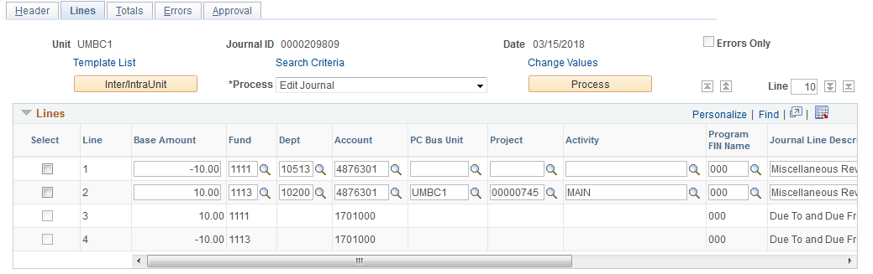
Please ignore these line with 1701000, they auto balance by fund.
To review the lines without the new 1701000 account numbers, the lines can be downloaded form the red box.

SUBMIT FOR APPROVAL

STEP 7: SUBMIT JOURNAL ENTRY
Since PeopleSoft Finance will house the journal and backup in the attachments, printing the journal is NOT REQUIRED. When the Journal is free of Errors, please continue to Submitting for Approval.
Please click the Approval Tab.
Next Click Submit button.
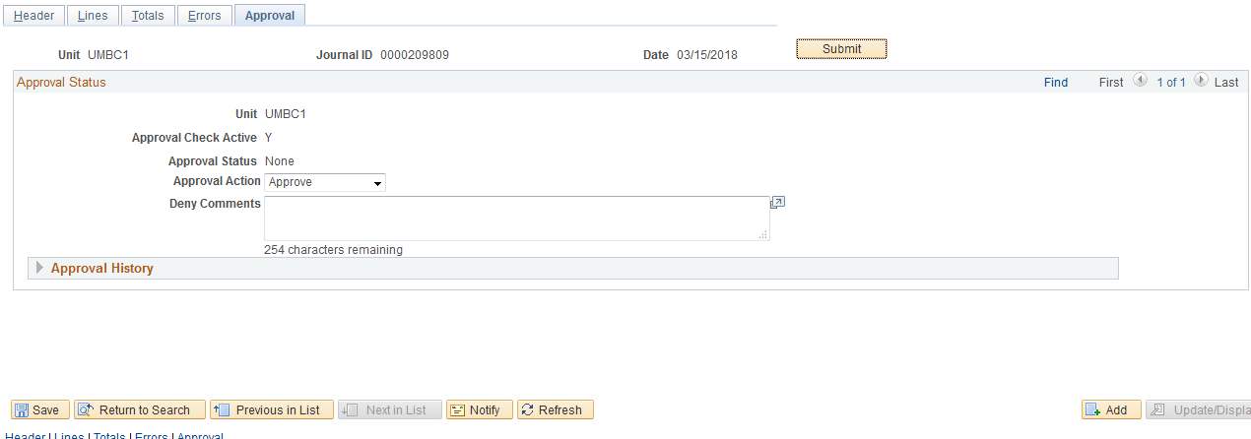

When the Journal is submitted for approval, it enters a “Worklist Item” to the Departmental Approvers for the department listed on the Journal Line 1.

STEP 8: JOURNAL APPROVAL INFORMATION

When the Journal is submitted for approval, it enters a “Worklist Item” to the Departmental Approvers for the department listed on the Journal Line 1.
To see who will be approving the journals, please click on the link in the “Pending” box. This example has one Fund Approval box, but other journals may have multiple.

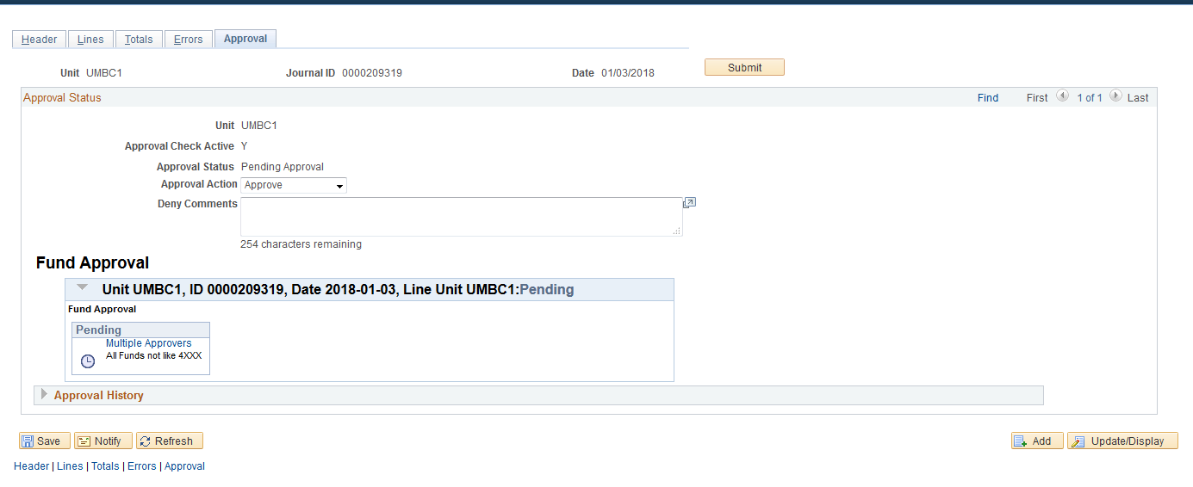

STEP 9: NOTIFY OTHER CAMPUS DEPARTMENTS
Business Process for “Notify”: Colleges or Units may have business processes to include more than one approver to notify. This Notify Button may be used to accommodate this business process. It can be used in conjunction with the “Attachments” feature.
There is also a step that an Approver can take, which is in the Approver’s Instructions.
Update the Workflow Notification Email:
- To:
- Subject
- Message
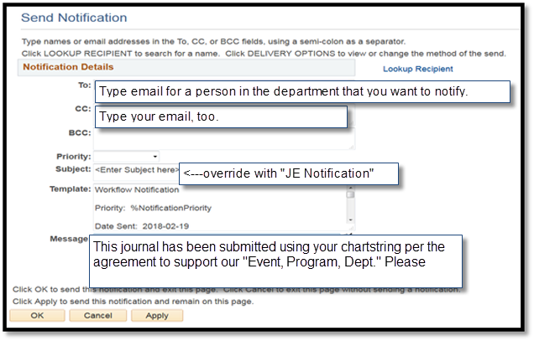

JOURNAL ENTRY FEATURES

STEP 10A: FIND AN EXISTING VALUE

Check the status of your keyed journals via “Find an Existing Value” menu. This also has a new feature to search by your USER NAME or Campus ID.
Search criteria can be saved
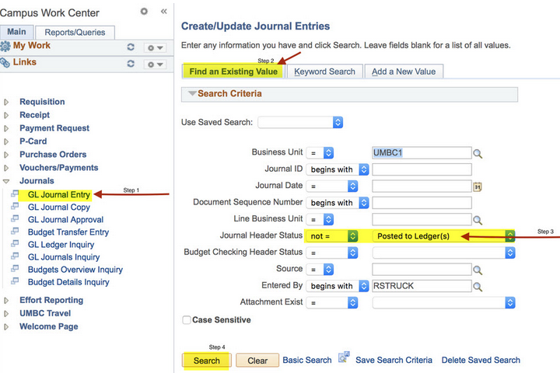

STEP 10B: JOURNALS TO TAKE ACTION LINK
During the Journal Edit Process, if you Answered ‘NO’, it is possible to use the links in the “My Work” section have been organized as below, to act as a reminder for you to take action on your journals:
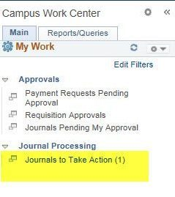
For the person that KEYED THE JOURNAL, there will be an item in the “Journals to Take Action” link, to act as a reminder, or to click on the hyperlink to take action.

It is possible to take actions from this screen, e.g. Submit for Approval, Check the Approval Tab, Edit again.

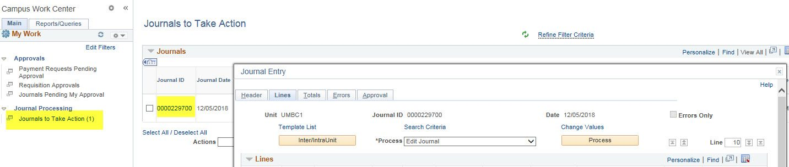

STEP 11: JOURNAL ENTRY COPY
On occasion, it is necessary to COPY or REVERSE a journal
To COPY a Journal,
- While in the Lines tab of a journal:
- Select the Process drop down box to be ‘Copy Journal’.
- Click Process

To COPY the original Journal, please:
- Ensure the date in Journal Date will be in the Fiscal Period you need.
e.g. 1/3/201X = Period 7
- Check Box ‘Recalculate Budget Data’
- Then click OK button at bottom left.
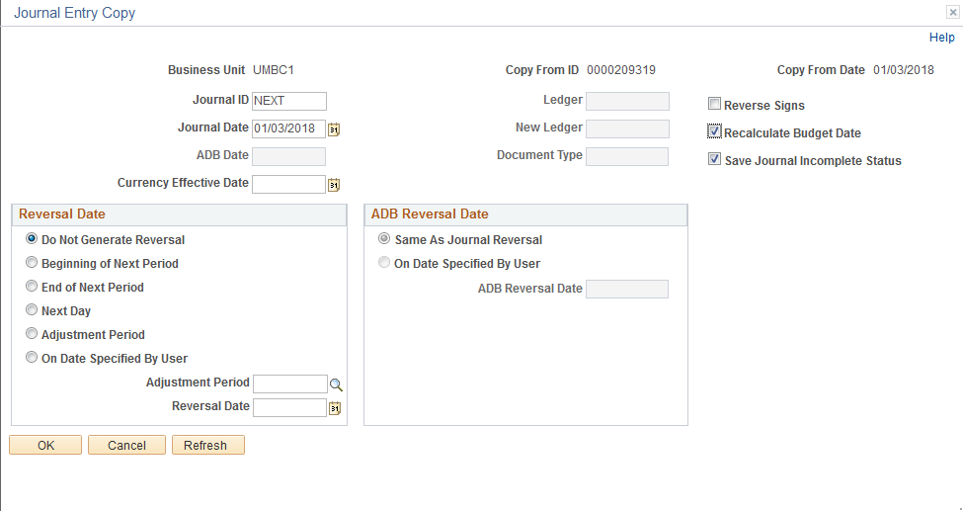

PLEASE REMEMBER TO ATTACH BACKUP TO THE “NEW COPY” of the JOURNAL.

STEP 12: JOURNAL ENTRY REVERSAL
To COPY with the objective of making a REVERSAL of a previous JE:
- While in the Lines tab of a journal:
- Select the Process drop down box to be ‘Copy Journal’.
- Click Process

Check the boxes below for:
- Reversal Signs Button
- Recalculate Budget Data
- Save Journal in Incomplete Status
- IMPORTANT: Ensure the date in Journal Date will be the Fiscal Period you need. e.g. 1/3/201X = Period 7

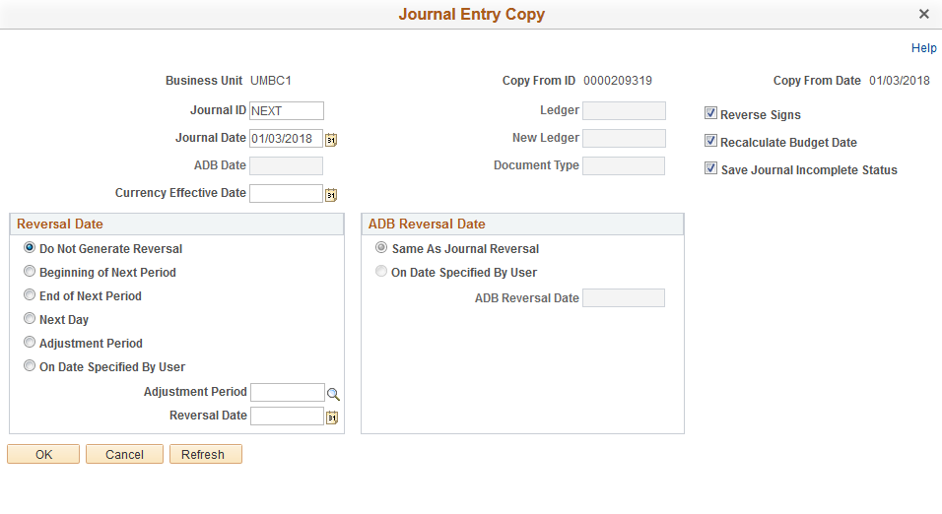
Once the original journal has been Reversed and recopied, please update the
- Journal Header: Long Description to explain why it is being reversed
- Journal Lines: Line Description shown on these instructions (if needed).
- Journal Lines: Reference shown on these instructions (optional).
- These appear on the General Ledger Detail reports so if you indicate that a journal is a REVERSAL and REDO of a previous journal, it will make research easier.
PLEASE REMEMBER TO ATTACH BACKUP TO THE “NEW COPY” of the JOURNAL.

APPENDIX A: JE HELPFUL HINTS 9.2
Field | Description | Values
Base Amount | Balance Sheet Accounts (Usually Central Use) 1,2,3 | DR (+) CR (-)
 | Revenue Accounts (Campus Wide) 4, 5 | DR (+) decrease revenue  CR (-) increase revenue
 | Expense Accounts (Campus Wide) 6,7,8 | DR (+) increase expense  CR (-) decrease expense
Fund | 1111 State Fund | * Journals with 1114,1253,1263 will be reviewed by OCGA.
 | 1112 Auxiliary Fund
 | 1113 DRIF or Revolving Fund
 | 1114* Cost Share fund for Grant
 | 1253* Grant Fund
 | 1263* Financial Aid
Prog FIN | Revenue Accounts / Balance Sheet | Must be 000
 | Expense Accounts | Never be 000
 | Expense Accounts –  Fund 1112 special rule | Must be 081 for expenses
Dept | Use Magnifying class to search.  e.g Enter 10% in the field then press ‘Look Up’ | Be careful typing Dept ID.
Account | Use Magnifying class to search.  e.g Enter 4, 5, 6, or 7 in the field Account field then press ‘Look Up’
PC BUS Unit | Needed for Projects | Blank if there is NO project
 |  | UMBC1 for UMBC projects
 |  | CAPPJ* for Facilities Mgmt
Project | Use Magnifying class to search. | FYI: List will only appear if UMBC1 is in PC BUS Unit.
Activity | Use Magnifying class to search. | Needed if Project field is populated
Journal Line Description | Enter information that will be helpful on Detail Reports – 30 characters long. See Appendix A
References | Enter information that will be helpful on Detail Reports – 10 characters long.

APPENDIX B: COMMON CHART STRING ERRORS
 | Error | Description | What to do?
COMMON  ERRORS | FIX_STRING | Project ID does not match either Fund or Department or Prog Fin | - Please run this query to determine correct fund:  UM_GL_VALID_FIX_STRING_COMBO
 | Error | Description | What to do?
COMMON  ERRORS | NO1111FUND or NO1112FUND | Department has no State Funds (1111) or  Auxiliary Funds (1112) | Ensure there is no typo, then contact department. If Dept has budgeted Fund 1111 or 1112, open RT ticket in Financial Services & Accounting Queue.
 | FUND_PROJE | E.g. Fund 1113 has been used without a PC BUS Unit or Project ID. | Confirm the chartstring.
 | UM_PROGFIN | The Prog FIN selected is intended for a different account type. | Change the Prog FIN based on the Helpful Hints.
 | Error | Description | What to do?
UN-COMMON  ERRORS | ACCT_FUND | Fund is required for transaction. | Enter the fund.
 | FS_DBT_SRV | Debt Service requires specific chartstring and departments. | Please review Ledger Inquiry for the previously accepted chartstrings.
 | FS_PAYROLL | The account selected is a system generated payroll department and is not available for manual journal entries. | Please check Tree Viewer for the Tree CC_ACCOUNTS. Look under the “6015099 Fringes – Manual Calc” for correct manual account.
 | UM_DPT_REQ | Department required. | Enter a Department ID.
 | UM_INVL_DP | Department / account is a roll up. It cannot have transactions directly charged to it. | Please check Tree Viewer to review CC_ACCOUNTS or CC_DEPT
 | UM_INVL_FD | Invalid Field. | Fix value.
 | UM_ROLLUP | Department or account selected is a roll up value, which means it cannot have transactions directly charged to it. | Please check Tree Viewer to review CC_ACCOUNTS or CC_DEPT
 | UM_SOF_X | Field Source of Funds (SOF) is no longer used. | Remove value from SOF.
SPECIAL RULE | FIXACCOUNT | Rule was designed for all modules except Journal Entry (JE). If this appears in JE, open RT ticket for Financial Services & Accounting. | In non-Journal Entry transaction, please use a different account number. This account must net to zero. The account that you are attempting to use cannot be used in any module other than Journal Entry.

APPENDIX C “COST TRANSFER PROCEDURES ON SPONSORED PROJECTS
Printed for class, but also available on OCGA Website: https://cga.umbc.edu/cost-transfer-procedures-on-sponso fred-projects-2/

